

**Yarmouk University**

**Hijjawi Faculty for Engineering Technology**

**Computer Engineering Department**

**CPE 563: Computer Networking Laboratory**

**Task 6: VLANs**

**Basic Information:**

|  |  |
| --- | --- |
| **Student Name:** |  |
| **Student ID:** |  |
| **Student Section Number:** |  |

**Objective:**

The objective of this lab is to study how to divide a physical network into a number of separate logical networks using virtual local area networks (VLANs) with the benefit of decreasing collision domain and adding more security.

**Background:**

Virtual LANs (VLANs) allow a single extended LAN to be partitioned into several seemingly separate LANs. Each virtual LAN is assigned an identifier (sometimes called a color), and packets can only travel from one segment to another if both segments have the same identifier. This has the effect of limiting the number of segments in an extended LAN that will receive any given broadcast packet. An attractive feature of VLANs is that it is possible to change the logical topology without moving any wires or changing any addresses.

**VLAN Configuration Guidelines**

Follow these guidelines when creating and modifying VLANs in your network:

* The switch module supports 1005 VLANs.
* Normal-range Ethernet VLANs are identified with a number between 1 and 1001. VLAN numbers1002 through 1005 are reserved for Token Ring and FDDI VLANs**.**

**Creating or Modifying an Ethernet VLAN**

To access VLAN configuration mode, enter the vlan global configuration command with a VLAN ID. Enter a new VLAN ID to create a VLAN, or enter an existing VLAN ID to modify that VLAN.

Beginning in privileged EXEC mode, follow these steps to create or modify an Ethernet VLAN:

|  |  |
| --- | --- |
| **Step** | **command** |
| Step 1: Enter global configuration mode. | configure terminal |
| Step 2: Enter a VLAN ID, and enter VLAN configurationmode. Enter a new VLAN ID to create a VLAN, or enter an existing VLAN ID to modify that VLAN. The available VLAN ID range for this command is 1 to 4094. *Note* Extended-range VLANs (VLAN IDs 1006 to 4094) are not saved in the VLAN database. | vlan vlan-id |
| Step 3: (Optional and supported on normal-range VLANsonly) Enter a name for the VLAN. If no name is entered for the VLAN, the default in the VLAN database is to append the vlan-id with leading zeros to the word VLAN. For example, VLAN0004 is a default VLAN name for VLAN 4. | name vlan-name |
| Step 4: Return to privileged EXEC mode | end |
| Step 5: Verify your entries. The name option is only validfor VLAN IDs 1 to 1005. | show vlan {name vlan-name | id vlan-id} |
| Step 6: (Optional) Save the configuration in the switchmodule startup configuration file. | copy running-config startup config |

To delete a VLAN, use the no vlan vlan-id global configuration command. You cannot delete VLAN 1or VLANs 1002 to 1005.

**Assigning Static-Access Ports to a VLAN**

You can assign a static-access port to a VLAN**.**

Beginning in privileged EXEC mode, follow these steps to assign a port to a VLAN in the VLANdatabase:

|  |  |
| --- | --- |
| **Step** | **command** |
| Step 1: Enter global configuration mode. | configure terminal |
| Step 2: Enter the interface to be added to the VLAN | interface interface-id |
| Step 3: Enable the port. | no shutdown |
| Step 4: Define the VLAN membership mode for the port(Layer 2 access port). | switchport mode access |
| Step 5: Assign the port to a VLAN. Valid VLAN IDs are1 to 4094. | switchport access vlan vlan-id |
| Step 6: Return to privileged EXEC mode. switchmodule startup configuration file. | End |
| Step 7: Verify the VLAN membership mode of the | show running-config interface interface-id |

**Configuring VLAN Trunks**

**Trunking Overview**

A trunk is a point-to-point link between one or more Ethernet switch module interfaces and another networking device such as a router or a switch module. Ethernet trunks carry the traffic of multiple VLANs over a single link, and you can extend the VLANs across an entire network. The switch module supports the 802.1Q industry-standard trunking encapsulation.

* If you do not intend to trunk across links, use the switchport mode access interface configuration command to disable trunking.
* To enable trunking, use the switchport mode trunk interface configuration command to change the interface to a trunk.

**Configuring a Trunk Port**

Beginning in privileged EXEC mode, follow these steps to configure a port as an 802.1Q trunk port:

|  |  |
| --- | --- |
| **Step** | **command** |
| Step 1: Enter global configuration mode. | configure terminal |
| Step 2Specify the port to be configured for trunking, andenter interface configuration mode. | interface interface-id |
| Step 3: Enable the port. | no shutdown |
| Step 4: Configure the interface as a Layer 2 trunk**.** | switchport mode trunk |
| Step 5: (Optional) Configure the list of VLANs allowedon the trunk.  For explanations about using the add, all, except,and remove keywords, see the command reference for this release. The vlan-list parameter is either a single VLAN number from 1 to 4094 or a range of VLANs described by two VLAN numbers, the lower one first, separated by a hyphen. Do not enter any spaces between comma-separated VLAN parameters or in hyphen-specified ranges. All VLANs are allowed by default. | **switchport trunk allowed vlan** {{**add** | **except** | **remove** } *vlan_list* | **all** | **none** } |
| Step 6: Return to privileged EXEC mode. switchmodule startup configuration file. | End |
| Step 7: Verify the VLAN membership mode of the | show running-config interface interface-id |

**Lab Work:**

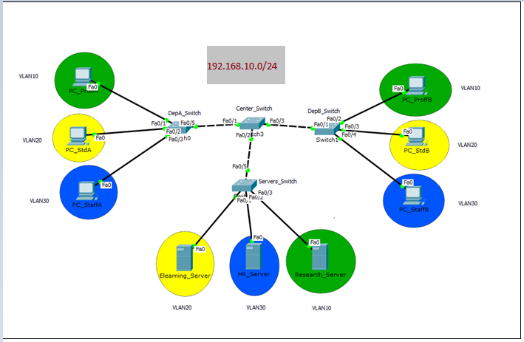

Fig 1

**Referring to the above figure (Fig 1):**

You have a network for a university with two departments A and B. Each department has a professor, a staff and a student. You should let the professors gain the access to the research server, and the staffs gain access to the HR_server and finally the students gain access to the ELearning server using VLANs.

**While you are preparing your report, always provide a screen shot for each question.**

**Before doing VLANs configuration, answer the following questions:**

1. **Try to ping from PC_StaffA to all other Pcs, what you find? Why?**

**Because they are all in the same network.**

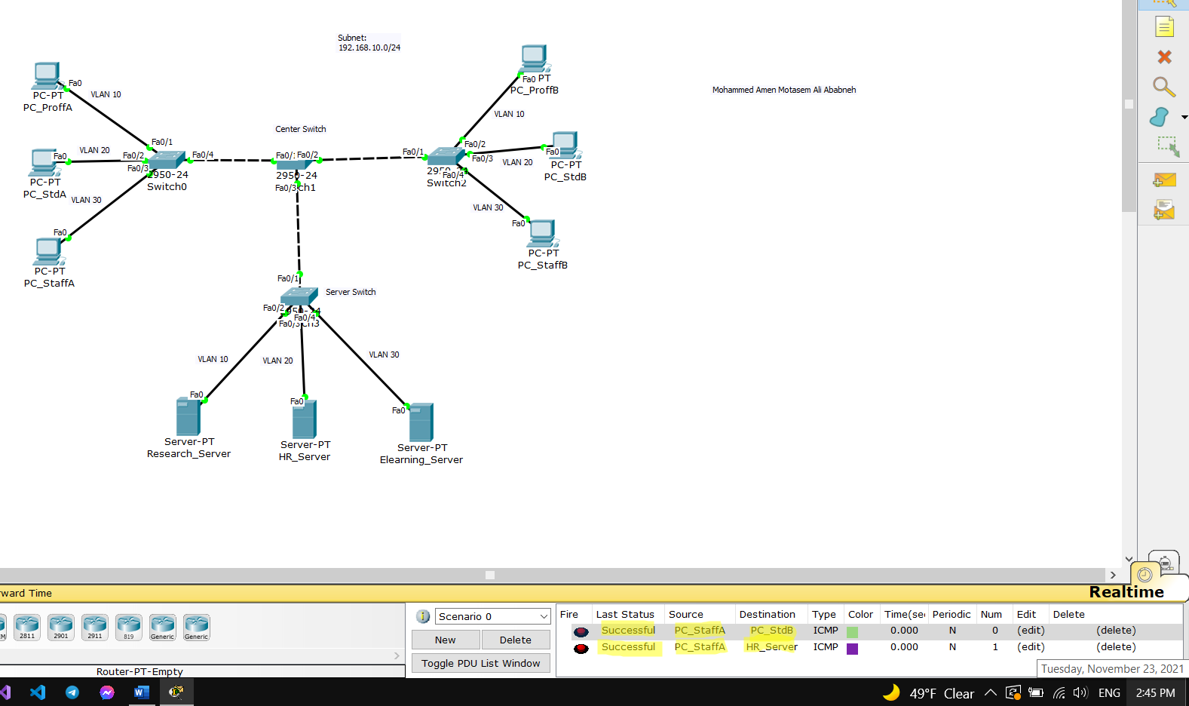

1. **Try to ping from PC_StdB to all the servers, does you trial succeed? Why?**

**Yes it did, because they are in the same network.**

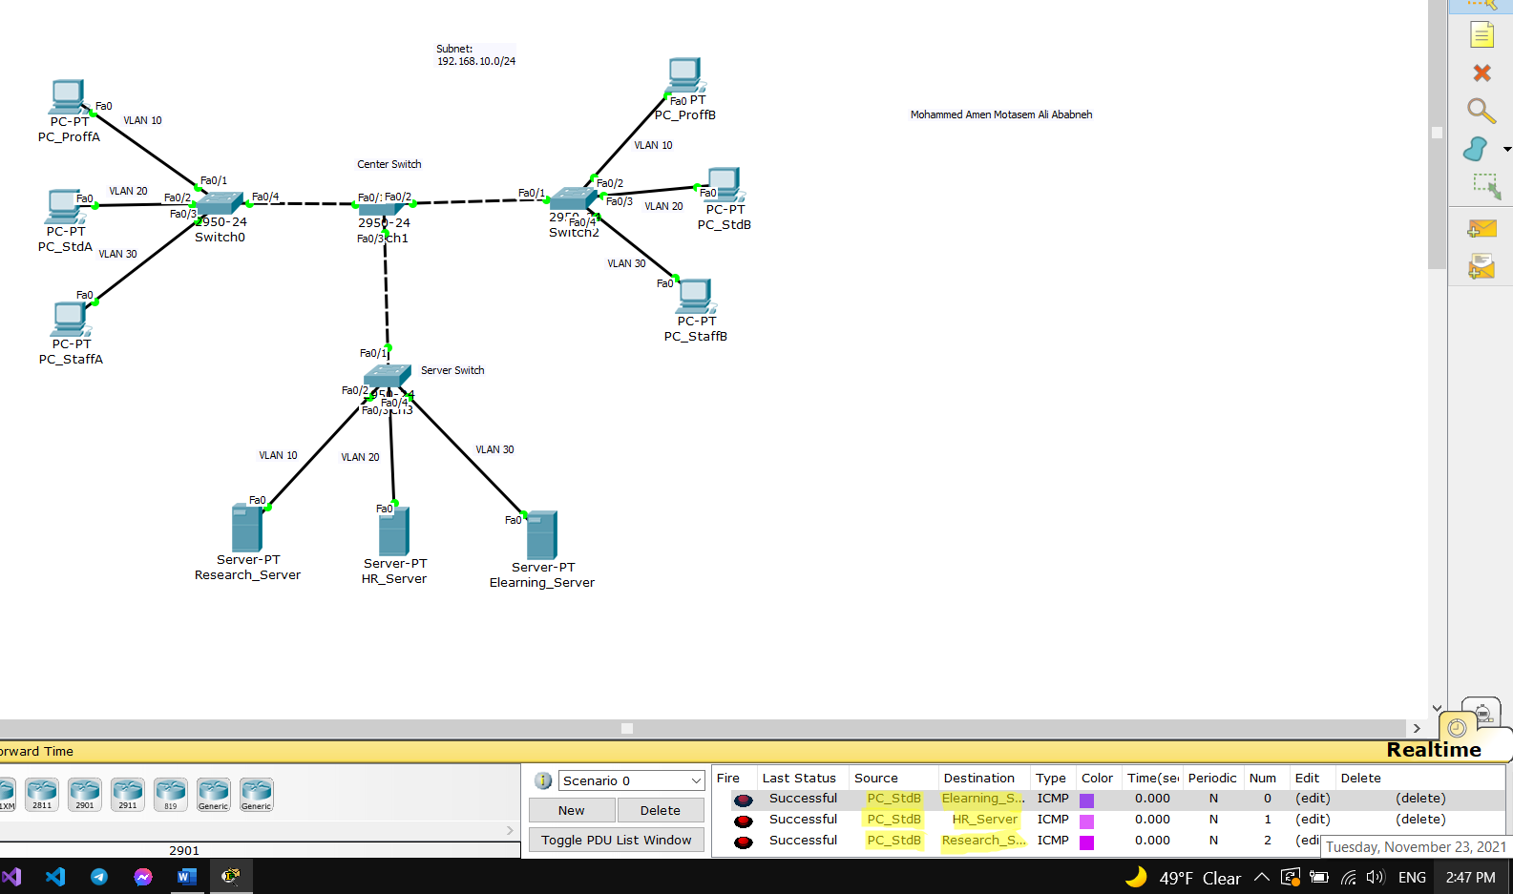

**After you finish VLANs configuration, answer the following questions:**

1. **For professors VLAN, test the connection between PC_ProffA, PC_ProffB and the Research_Server, does it succeed? Yes it did**

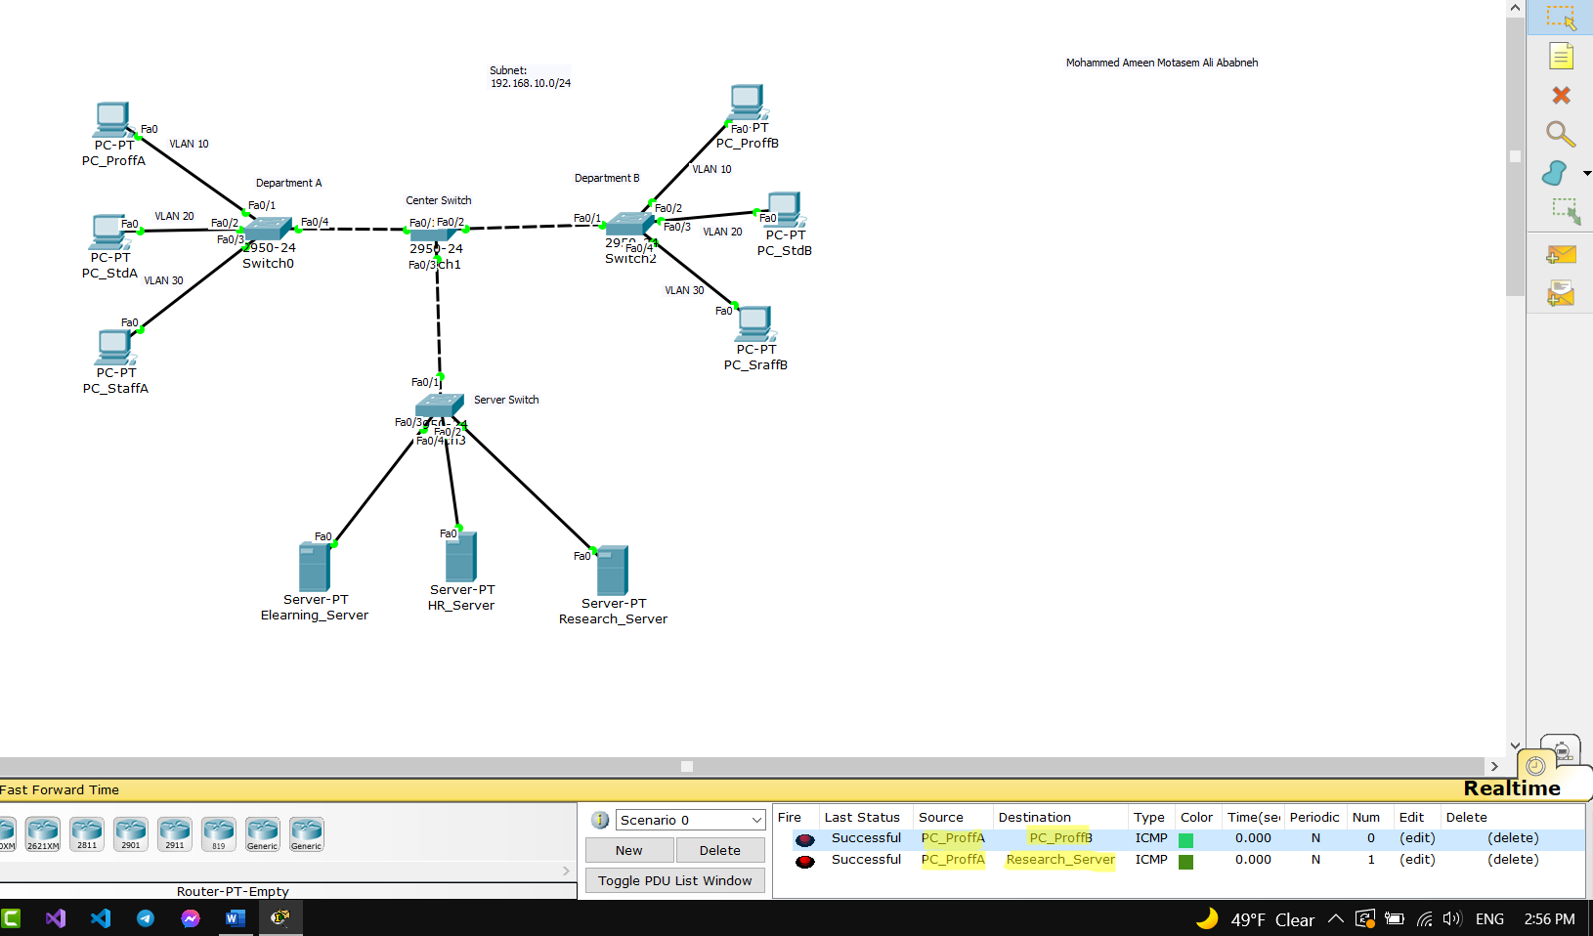

1. **For Staffs VLAN, test the connection between PC_StaffA, PC_StaffB and the HR_Server, does it succeed? It only work for the ping between pc_staffa and pc_staffb, the ping between the PC’s of the two student does not work with the HR_Server.**

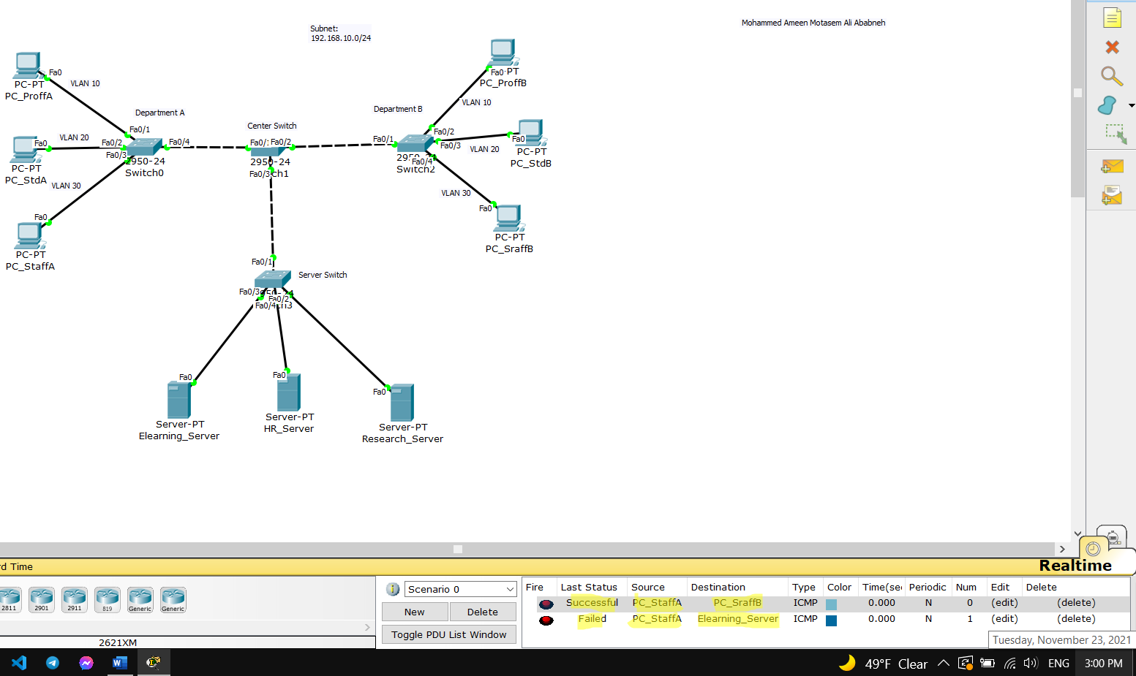

1. **For Students VLAN, test the connection between PC-StdA, PC_Std_B and the Elearning_Server, does it succeed? Yes, it did.**

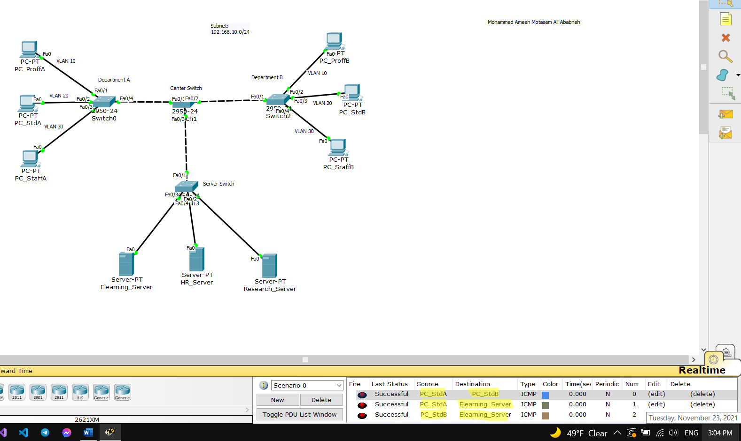

1. **Try to ping from students Pcs to HR_Server, does it succeed? No it doesn’t work at all.**

